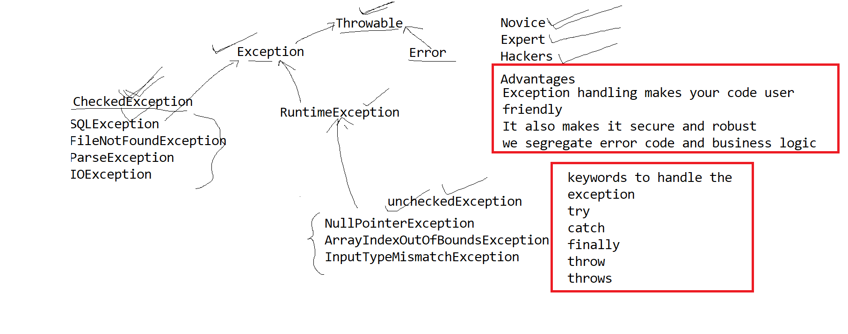

---one try block has to be followed by minimum one catch block or finally block

----follow the class hierarchy while handling exceptions

---when any exception occurs JVM will generate object and throws it, and try block will terminate.